~Asia-China-Mirror-Warring States-(475-221 BCE)-Arc 16-Inscription 22 Characters

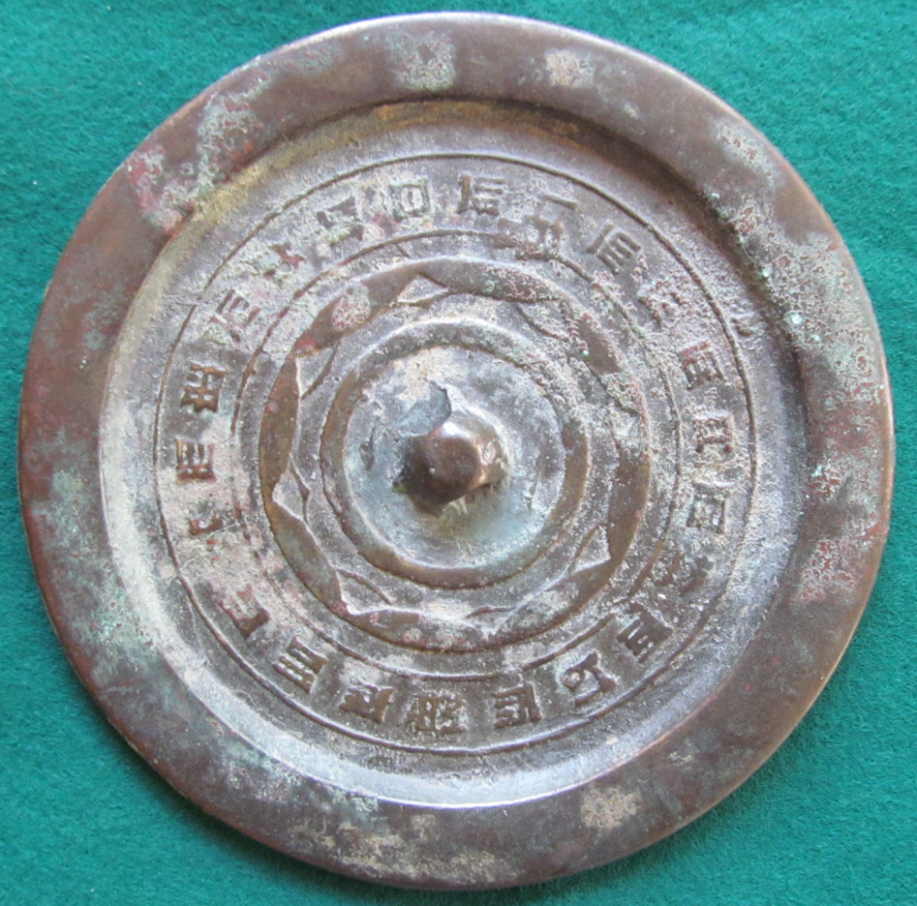

The interesting thiing about this continuous arc mirror is that each of the eight continuous arcs is conjoined with a separate non-continuous arc making a total of 16 arcs. It has a 22 character inscription.